ONR Transport Competent Authority Newsletter
Quarter 1 2023/24

Introduction

Welcome to the newsletter from our Transport Competent Authority (TCA).

The TCA is the competent authority, under the Carriage of Dangerous Goods and Use of Transportable Pressure Equipment Regulations 2009 (CDG), for the movement of Class 7 (Radioactive) material by road, rail and inland waterways within Great Britain.

The TCA provides support to the other UK competent authorities with respect to transport by Sea and Air, and by land in Northern Ireland. ONR is also the enforcing authority for the Ionising Radiation Regulations 2017 (IRR17) with regards to transport.

This newsletter aims to provide a regular update to all dutyholders, with information relevant to the transport of radioactive material within the UK.

The TCA provides generic guidance and support on how dutyholders can comply with the legal requirements via our website and stakeholder events, this newsletter is part of that approach. For advice on specific transport activities, dutyholders should consult their Radiation Protection Advisor (RPA) and/or Dangerous Goods Safety Advisor (DGSA).

Inspections and compliance activity

We undertake a programme of planned compliance inspections of dutyholders that have transport responsibilities. Inspections are undertaken physically at dutyholders’ premises or remotely as appropriate.

During the 2022/23 financial year our inspectors carried out routine planned compliance inspections and we noted the following common issues:

- Transport Radiation Risk Assessments not being suitable and sufficient.
- Inadequate or absent transport emergency arrangements.
- Inadequate management systems.
- Failing to appoint in writing appropriate Radiation Protection Advisers (RPAs), receiving advice from unappointed RPAs or from Health Physicists who are not RPAs.

  - Dutyholders must be able to provide evidence of formal RPA appointment(s) in writing as required by IRR17 Regulation 14(2).

  - It is the responsibility of transport dutyholders to appoint suitably qualified and experienced individuals who are accredited RPA(s) or an RPA Body to provide advice on transport activities. More information on this can be found on our website at https://www.onr.org.uk/transport/radiation-protection-advisors.htm. Note that each accredited RPA must be appointed in writing by the dutyholder and that only companies approved by the Health and Safety Executive (HSE) to act as an RPA body may use non-accredited RPAs (Health Physicists) to provide advice as part of the RPA body.

  - The HSE RPA statement of competence which can be found on HSE’s website at https://www.hse.gov.uk/radiation/rpnews/statementrpa.htm requires RPAs to have a basic understanding of relevant transport regulations (including for example the Carriage of Dangerous Goods and Use of Transportable Pressure Equipment Regulations 2009 [as Amended] as relating to Class 7) and other relevant legislation (including the Radiation [Emergency Preparedness and Public Information] Regulations 2019 [REPPIR19]).

  - RPAs and RPA bodies should be able to demonstrate that they have the necessary knowledge and experience to make them suitable to appropriately advise transport dutyholders.

  - Dutyholders must ensure that advice on IRR17 and, for transit premises where appropriate, REPPIR19 is obtained from RPA(s), is clearly documented and acted upon. Further information about transit premises and REPPIR19 can be found on our website at https://www.onr.org.uk/documents/2020/reppir19-transit-premises.pdf.

- Failing to appoint and seek advice from appropriate Dangerous Goods Safety Adviser.
  - DGSAs should be suitably trained and hold the road/rail all classes qualification.
  - For DGSAs advising dutyholders on class 7 dangerous goods, the additional class 7 training course, based on the syllabi provided by the Radioactive Materials Transport Users Committee (RAMTUC), is recognised by ONR as Relevant Good Practice (RGP). The syllabi developed for this course programme are designed to meet legal training duties laid on the industry and to provide appropriate operational and management skills to those with duties affected by the transport regulations.
  - DGSAs should also be able to demonstrate that they have the necessary knowledge and experience to make them suitable to appropriately advise dutyholders.

  - ONR expectations are that appointed RPA(s) and DGSA(s) attend dutyholder sites on a routine basis to gain and maintain an understanding of all aspects of dutyholders’ transport activities.

Incidents and operational experience

Dutyholders are required to inform ONR of transport incidents via our INF1 reporting process; these, along with previously reported incidents, are reviewed on a regular basis.

Incidents should be reported using the process identified on the http://www.onr.org.uk/notify-onr.htm page.

There is a requirement to provide a follow up report within 60 days of an incident report. Guidance on the content of this report is provided on the Notify ONR page. The intent of the report is to identify learning and any changes implemented as a result of the incident.

Enforcement

Where non-compliances are identified during compliance inspections or following reported events, ONR will consider enforcement action in accordance with its Enforcement Policy Statement (https://www.onr.org.uk/documents/enforcement-policy-statement.pdf).

Over the previous financial year, we have served three prohibition notices and three improvement notices. Further information on these notices can be found on the ONR website:

https://news.onr.org.uk/2022/04/prohibition-notice-issued-to-the-university-of-manchester/
https://news.onr.org.uk/2023/02/onr-issues-prohibition-notice-to-breedon-trading-ltd/
https://news.onr.org.uk/2023/04/onr-issues-prohibition-notice-to-sai-g-logistics-ltd/
https://news.onr.org.uk/2022/05/improvement-notice-issued-to-ge-healthcare-ltd/
https://news.onr.org.uk/2022/10/improvement-notice-issued-to-place-2-place-logistics/
https://news.onr.org.uk/2023/02/onr-serves-improvement-notice-on-dnata-ltd/

Stakeholder engagement

SRP Webinar

In December 2022, we presented an ‘introduction to transport regulation’ webinar on behalf of the Society for Radiological Protection (SRP) to over 300 delegates. You can watch the webinar through the SRP YouTube channel. https://www.youtube.com/watch?v=MYKp1eF4Gwk

2nd ONR TCA Stakeholder event

In March 2023, 41 representatives from the transport community attended the 2nd ONR TCA stakeholder event, with the first taking place in 2019.

The purpose of the event was for stakeholders to meet ONR TCA inspectors face to face, network, understand how ONR TCA operates and promote discussion on Class 7 dangerous goods transport regulation.

There were presentations by ONR to provide an overview of the TCA’s role and responsibilities, Nuclear Transport Solutions and the National Carriage of Dangerous Goods practitioners forum.

In the afternoon a workshop session provided stakeholders an opportunity to share their experiences of interacting with ONR and discuss ways of improving ONRs approach to regulating the civil transport of class 7 dangerous goods.

ONR TCA will review feedback and the questions asked during the Q&A sessions to help steer future ONR TCA strategies.

Initial response to feedback given during the event includes publication of updated TCA webpages https://www.onr.org.uk/transport/index.htm and a revision to our Five Steps to Transport Emergency Planning guidance https://www.onr.org.uk/transport/five-steps-transport-emergency-planning.docx

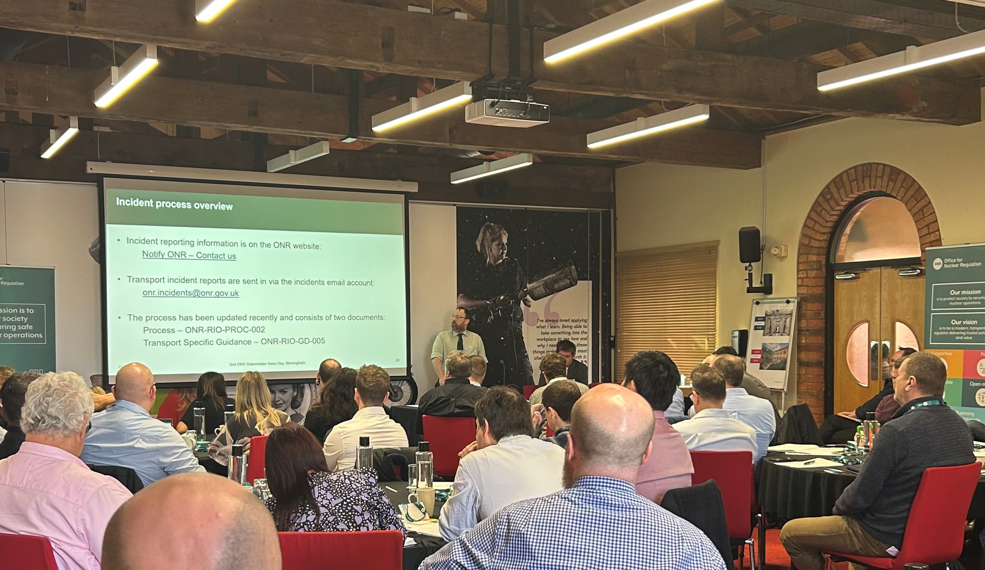

Changes to regulations and ONR guidance

Radiation Risk Assessments (RRAs)

Our guidance on transport RRAs was updated and published in November 2022 to clarify where an emergency ends and the requirement to estimate accident doses.

The guidance can be found at: https://www.onr.org.uk/operational/other/td-tca-gd-003.docx

Five Steps to Transport Emergency Planning

Our guidance on transport emergency planning was updated and published in May 2023.

The guidance can be found at: https://www.onr.org.uk/transport/five-steps-transport-emergency-planning.docx

Emergency planning

The 2019 amendments to CDG09 have now been in place for three years. There is a requirement on dutyholders who have emergency plans to test every 3 years and the findings reported to ONR. If you have tested your emergency plan recently, send your report to class7@onr.gov.uk.

ONR's expectation is that tests should be carried out approximately annually although there is no requirement to report these interim tests to ONR.

International

The IAEA is starting a revision cycle for SSR-6 with the process starting in 2023, as part of this there has been a review of A1/A2 values which is proposing some changes to the current values.

The following table contains the working groups proposals and a comparison with the current A1/A2 values.

https://www-ns.iaea.org/committees/files/TRANSSC/2206/NewTable2.xlsx

ONR has identified this aspect as being significant to the whole Class 7 transport industry and so is requesting feedback from all our dutyholders.

If you have any concerns regarding the proposed changes can you please notify ONR, ensuring that you include the following specifics:

- Radioisotope;
- Material form;
- Current transport methods – Quantities moved (individual/annual), package type;
- Impact of the change to your usage – i.e. increase in transport movements, needing to move from Type A to Type B package, etc.; and
- Significance of the change – number of packages/movements per year, cost implications.

ONR will review feedback and present it to the IAEA as part of the UK input into the revision process for SSR-6.

Frequently asked questions (FAQs)

ONR TCA regularly receives questions from dutyholders. ONR will try to respond to these and will share answers to any frequently asked questions in these newsletters.

Please note ONR TCA can only provide responses to FAQs which relate to legislation and guidance, for any other queries please contact your appointed RPA or DGSA.

Our FAQ webpage has been updated as part of our update of TCA webpages:
https://www.onr.org.uk/transport/transport-faqs.htm

Feedback/contact us

What information do you think should be included within the TCA newsletter?

If you want to provide feedback or need more information regarding the transport of Class 7 dangerous goods our contact details are below:

E-mail: contact@onr.gov.uk
Website: ONR - Transporting radioactive material

