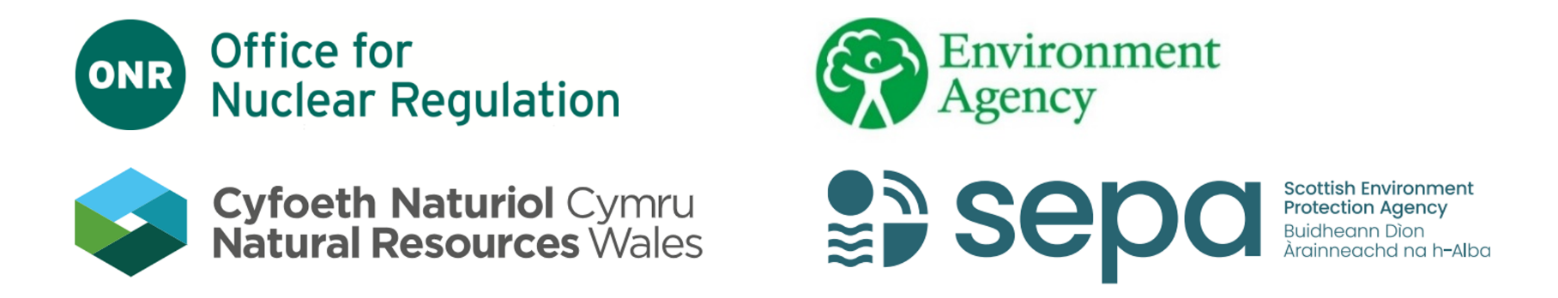

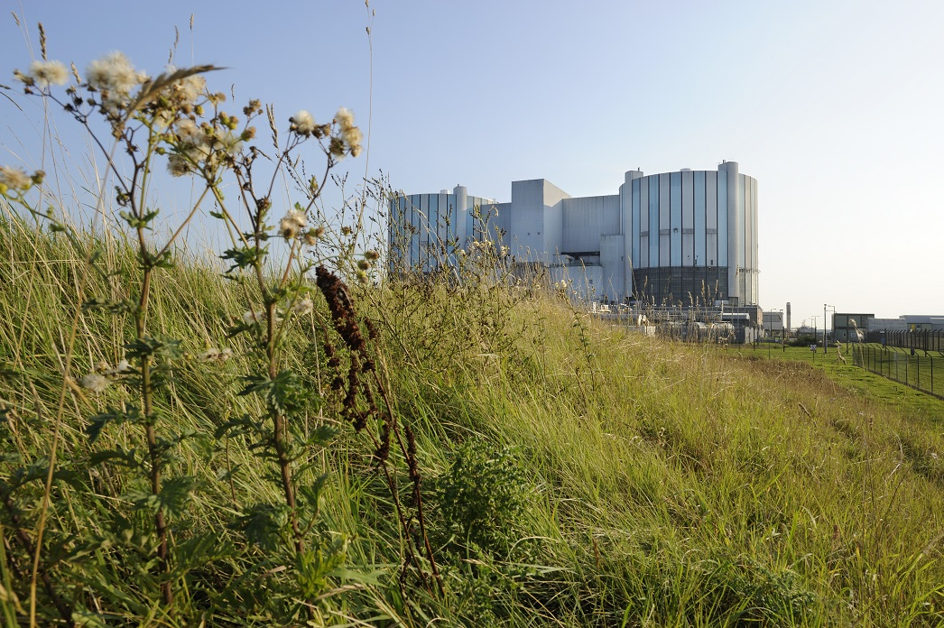
Regulatory expectations for successful land quality management at nuclear licensed sites

Regulatory expectations for successful land quality management at nuclear licensed sites
Joint advice note from the Office for Nuclear Regulation, the Environment Agency, Natural Resources Wales and the Scottish Environment Protection Agency

Revision 2

October 2024

Any enquiries related to this document should be sent to contact@onr.gov.uk

Revision 2 – October 2024
The joint advice on regulatory expectations for successful land quality management at nuclear licensed sites was first published in 2014. Revision 2 updates the joint advice note to reflect the Land Quality Management (LQM) interfaces with the environment agencies’ “Management of radioactive waste from decommissioning of nuclear sites: Guidance on Requirements for Release from Radioactive Substances Regulation” (the GRR), published in 2018. Implementation of the GRR has resulted in the requirement under the environmental permit or authorisation for operators to develop a Waste Management Plan (WMP) and Site Wide Environmental Safety Case (SWESC).

Purpose of this document
This joint advice note sets out the expectations of the Office for Nuclear Regulation (ONR), the Environment Agency (EA), Natural Resources Wales (NRW) and the Scottish Environment Protection Agency (SEPA) for successful management of land quality at nuclear licensed sites. It describes our overarching objective for LQM and identifies five key principles we expect nuclear site licensees and operators to have regard to. Many of these principles are also reflected in relevant permit and licence conditions.
Our purpose in publishing this joint advice note is to highlight that whilst we have different regulatory purposes, our expectations are complementary in seeking to achieve similar outcomes. As such, the overarching objective and supporting principles advocate a consistent, integrated approach to LQM that is independent of the nature of the contamination in order to achieve the best overall outcome.
LQM refers to the prevention of contamination of land and the water environment, and the assessment and remediation or clean-up (including control and monitoring) of radioactive and non-radioactive contamination. Where we refer to ‘contamination of land and the water environment’, we consider that to include contamination on the surface of the ground and in the ground, groundwater and surface waters. We note that impacts on surface waters on the site, and surface or marine waters off the site, will often be via groundwater. We do not consider radioactivity in the environment from lawful discharges to constitute contamination that should be subject to LQM.
We consider that LQM includes management activities that should occur irrespective of whether or not any contamination exists e.g. implementing preventative measures, site surveillance and planning for incident response. If there is contamination, then LQM activities should include risk assessment and where necessary the implementation of proportionate and sustainable remediation. We expect remediation to achieve standards that will ultimately not require further specific regulatory controls on the site, will optimise future waste production and enable the beneficial re-use of the land.
Climate change should be considered in all stages of LQM. Options should be selected, designed and implemented so that they are resilient, and don’t contribute more than is necessary, to climate change.
Although there is a considerable body of literature and experience associated with the management of land contamination internationally, it should be recognised that the waste management and decommissioning policies and regulatory frameworks in the UK have some differences. International standards and approaches to remediation or other management options may not be compatible with situations in the UK.
We encourage nuclear site operators to engage early with us to achieve a more detailed understanding of our requirements and guidance applicable to their sites, some of which can be found in the Further Reading section.

Principles for successful land quality management at nuclear licensed sites

Overarching objective
Operators should take all reasonably practicable measures to prevent contamination and to ensure that if it occurs, or if it has already occurred, it is managed safely and unacceptable risks to people or the environment are mitigated. This includes acting in a proportionate way, putting sustainability at the heart of how land quality management is planned and carried out.
To achieve the overall objective, we expect licensees and operators to address our expectations and demonstrate an integrated and holistic approach to LQM at the site through application of five key principles, as described below and shown in figure 1.

1. Establish strategies and plans for land quality management
Develop, maintain and implement a robust overall strategy for LQM, covering radioactive and non-radioactive contamination, supported by integrated implementation plans.

2. Prevent new contamination of land or the water environment
Ensure adequate control or containment is always maintained, so far as is reasonably practicable, to prevent leak or escape leading to contamination of land or the water environment.

3. Understand the land quality and contamination characteristics of the site
Gain adequate understanding of the site and surrounding area through appropriate targeted characterisation, investigation, risk assessment, monitoring and surveillance. For new build installations and facilities this should start before construction commences and be used to help establish baseline conditions.

4. Manage land quality to mitigate safety and environmental risks
Assess and prioritise options for LQM, applying the waste management hierarchy and implementing sustainable remediation practices, to deliver outcomes that reduce risks to acceptable levels, and for radioactivity to as low as reasonably practicable (ALARP) utilising the best available techniques (BAT) or best practicable means (BPM).

5. Work with stakeholders and other interested parties
Work with and enable the participation of interested parties, both internal and external, to build and maintain dialogue in support of achieving the overall best outcome.
Underpinning each of these principles is the need to maintain fit-for-purpose LQM records and manage the relevant knowledge appropriately, including for future generations where appropriate.
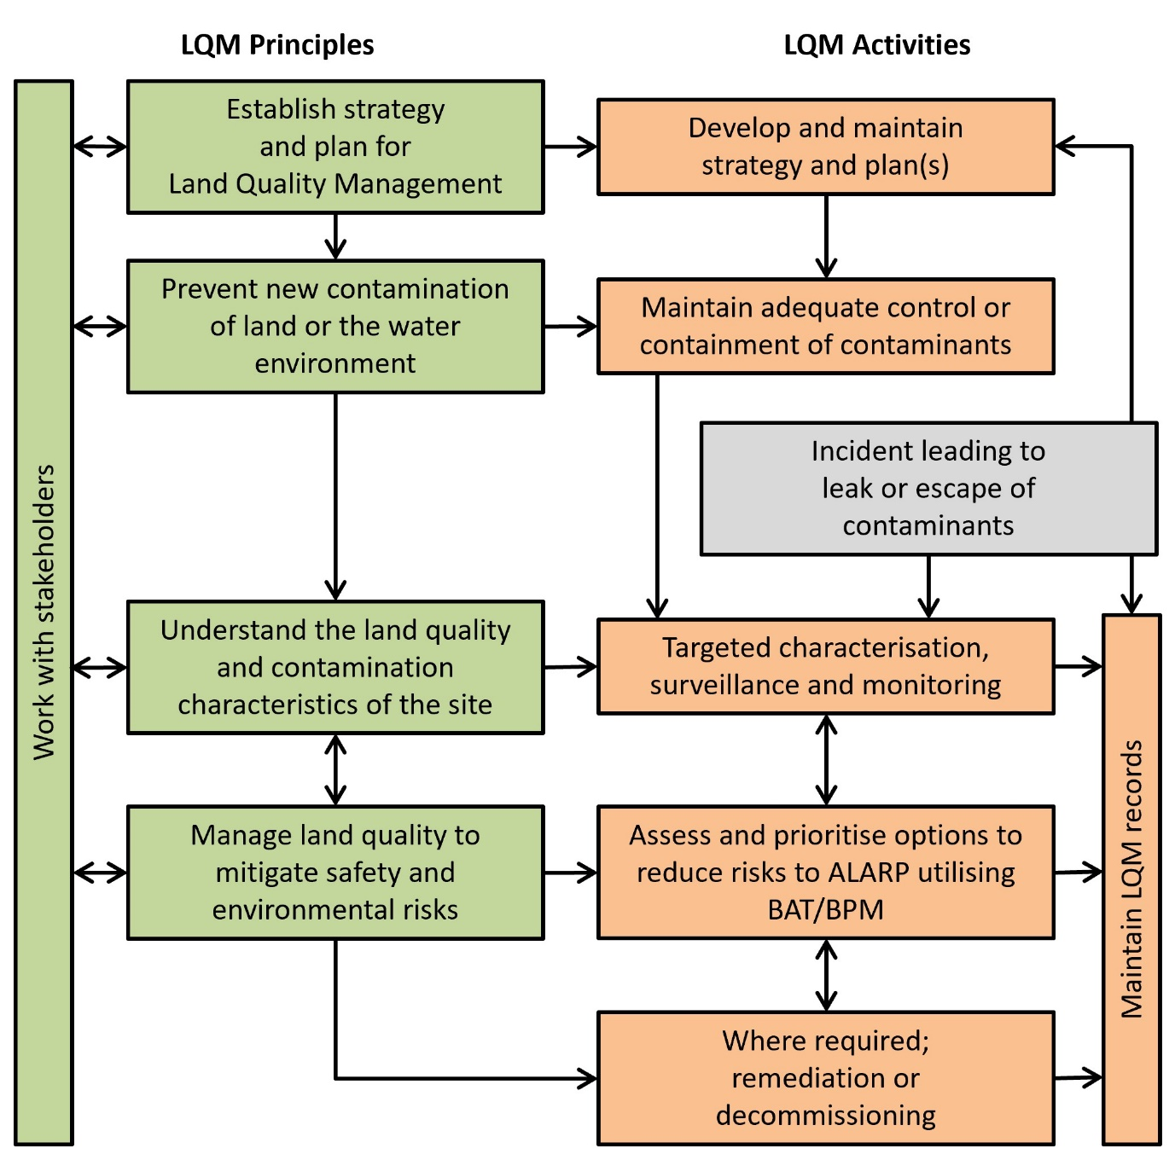
Figure 1. LQM principles and related activities

Principle 1 – Establish strategies and plans for Land Quality Management
Develop, maintain and implement a robust overall strategy for LQM, covering radioactive and non-radioactive contamination, supported by integrated implementation plans.
As part of its formal management arrangements, operators should establish strategies and plans for LQM activities, recognising wider activities across the site and ensuring that the objective of LQM at each site is clear, proportionate and agreed with all relevant local regulators. As a minimum, the strategy should recognise relevant stakeholder expectations or requirements (including those of the local community) for site management and subsequent re-use of the land, including any agreed interim or final site end states and dates.
The strategy should set out what is to be achieved through LQM and be supported by a plan that sets out ‘how’ LQM is delivered and relevant timescales. The strategy and plan should work together cohesively such that any change in one is considered in terms of whether it needs to be reflected by a change in the other. The relationship between the two elements (strategy and plan) is vital to ensuring that the various LQM activities work to a common sense of direction or purpose.
Equally essential is clarity about how the LQM strategy and plan integrates with other plans and legal requirements e.g. The Nuclear Reactors (Environmental Impact Assessment for Decommissioning) Regulations 1999. Characterisation outputs from implementation of the LQM plan will inform decommissioning plans, the WMP, and be considered as part of the SWESC to support removal of the site from regulatory control in future. The implementation of remediation will often result in the generation of radioactive waste and have a bearing on the WMP and the SWESC. Similarly, changes to decommissioning plans or WMP could inform changes to the LQM strategy and/or plan.
There should be a single coherent plan for LQM activities at a site, to be developed and implemented by the licensee and/or operator. The plan should set out key objectives, milestones, timescales and responsibilities, and make clear reference to LQM enabling procedures and arrangements such as record keeping, quality assurance, decision-making and stakeholder engagement. Both the strategy and plan should be subject to appropriate stakeholder engagement and reviewed and updated as necessary at regular intervals.
The development of all of the above strategies, plans and cases should be systematic and the approach to their development and management should be fully integrated and iterative.
All land and groundwater contamination should be managed in accordance with appropriate safety cases, environmental safety cases and waste management arrangements and plans, to demonstrate that risks to operating staff, to other persons and to the environment are avoided, so far as is reasonably practicable.

Principle 2 – Prevent new contamination of land or the water environment
Ensure adequate control or containment is always maintained, so far as is reasonably practicable, to prevent leak or escape leading to contamination of land or the water environment.

In the first instance arrangements should be in place to prevent the contamination of land and groundwater. Where contamination has already occurred arrangements should be in place to assess and remediate the contamination, whether on or arising from the nuclear licensed site.
All potential sources of contamination should be designed, constructed and maintained to prevent leaks as far as is reasonably practicable. This means considering both fixed and mobile sources, including those above and below the ground. Priority should be given to those sources that present the highest hazard and/or risk to land and water. Options for leak prevention could include adoption of non-liquid processes, conversion of waste to a passive solid form, multi-barrier containment and external bunding.
There should be a means of detecting leaks or otherwise proportionate monitoring of the condition of all potential sources of leaks, so far as is reasonably practicable. Contingency plans should exist and have been agreed with the regulators where appropriate, ready for implementation in the event of any leak occurring. Disposals of radioactive waste must only be made in accordance with relevant environmental permit or authorisation conditions.
Arrangements should exist to ensure that monitoring, leakage control and detection systems (including those that form part of any contingency plans) are appropriately inspected, tested and maintained.
If new contamination occurs, its potential risk or hazard and its physical extent should be assessed quickly, and appropriate and proportionate remediation undertaken to control the impacts on land and water quality, particularly groundwater. Any leak that is detected should be stopped or otherwise controlled to prevent continuation or recurrence of contamination. Such incidents should be notified/reported to the relevant regulator(s) in accordance with incident reporting arrangements.
All reasonably practicable measures should be used to control the spread of contamination (whether new or existing) and to assess (e.g. through monitoring and modelling) the actual and likely future extent and consequences of its impacts.
Site-wide arrangements should recognise the possibility of incidents and accidents occurring and should include activities to mitigate and manage leaks and escapes of any contaminants (radioactive or non-radioactive).

Principle 3 – Understand the land quality and contamination characteristics of the site
Gain adequate understanding of the site and surrounding area through appropriate targeted characterisation, investigation, risk assessment, monitoring and surveillance. For new build installations and facilities this should start before construction commences and be used to help establish baseline conditions.
The LQM plan and WMP should be based on thorough knowledge and understanding of the characteristics of the site and surrounding area, now and in the past, and any contamination that may exist. The plans should also consider how the site and any contamination are predicted to change in the future, including due to the possible impacts of climate change, natural disruptive events or new construction activities, and how any adaptations to these can influence the strategies and plans.
The extent of site characterisation (including characterisation of any contaminants) should be sufficient to understand the potential and existing sources of contamination, pathways, and receptors. Site characterisation activities should also allow any changes to be monitored and managed (including any changes in the influence of external factors on the site, for example landscape change because of coastal erosion or increases in risk of flooding owing to climate change). In the event of any contamination occurring or being suspected, site characterisation activities should allow the extent, behaviour, and migration of contamination to be understood or predicted, and an appropriate level of control to be exerted.
Site characterisation should be used to establish and then refine a conceptual site model which describes the pathways by which contamination from a source could reach receptors, and the risks posed to those receptors. This conceptual model should also set out baseline conditions (recognising temporal or spatial variation and uncertainties) against which any subsequent changes can be reviewed, and their potential impacts assessed. This is particularly important for new build sites or facilities. Where land quality issues are potentially significant, more detailed characterisation of the source term, pathways and receptors may be necessary. Where appropriate and proportionate this may also include the use of models to aid understanding of the geology, hydrogeology, geochemistry and contaminant fate and transport.
It is essential that prompt characterisation and risk assessment takes place on finding any new contamination, whether due to previously undetected sources or worsening impacts from known sources. Where appropriate, ongoing monitoring of contamination should be carried out.

Principle 4 – Manage land quality to mitigate safety and environmental risks
Assess and prioritise options for LQM, applying the waste management hierarchy and implementing sustainable remediation practices, to deliver outcomes that reduce risks to acceptable levels, and for radioactivity to as low as reasonably practicable (ALARP) utilising the best available techniques (BAT) or best practicable means (BPM)

Assess the options for land quality management
LQM decisions should be informed by the conceptual understanding of the site at the time and periodically revisited. Where risks are considered unacceptable, an assessment of options for remediation for those land and groundwater contamination source–pathway–receptor linkages should be carried out, taking account of the overall remediation strategy for the site. An appropriate level of stakeholder dialogue should occur early in the process of identifying, screening, and selecting remediation options. Option assessment includes consideration of:
- the physical and chemical nature and current state of contaminants
- the actual or potential risks to people and the environment under current and likely future conditions
- the benefits and detriments that implementation of each option would bring, including social, economic, and environmental
- the impact that any delay in implementing the option might have upon the spread of contamination
- the actual or potential risks associated with each option, and the costs of implementation
- the nature and volume of wastes (radioactive and / or directive wastes) that would be generated, and availability of disposal routes
- the lifecycle impacts on people and the environment
- the practical issues of implementation associated with each option, including the need for other regulatory authorisations
- the intended site end states (interim and/or final)
- the extent to which each option addresses any concerns raised by stakeholders
The aim should be to identify the most effective and sustainable remediation option or range of options that can achieve the desired outcomes.

Prioritise land quality management activities
The outcome of the assessment of remediation options should form the basis of a prioritised programme of work to implement the selected option(s) and should be reflected in relevant LQM and waste management plans.
LQM activities should integrate fully with other site restoration and waste management activities, both current and future. Contaminated areas of land or water requiring intervention should be remediated to appropriate standards unless it can be clearly demonstrated that to do so would not be reasonably practicable or aligned to sustainable remediation practices.
Where appropriate, opportunities should be taken for characterisation or remediation when civil works are being undertaken and before any new construction. Plans for other site activities should take account of the potential impact that any new development might have on any land and groundwater contamination (for example, impacting local groundwater flows and so changing contaminant migration rates or pathways) or any implemented management measures (for example, remediation or monitoring infrastructure).
The order in which remediation work is undertaken will generally reflect the risk posed to people and the environment from the area of concern. The highest priority for action should be given to those areas posing the greatest hazard and risk. LQM activities should continue throughout the period that the site remains under regulatory control, including any periods of monitoring.
Any change to planned management activities should be justified and the reasons for the changes clearly recorded.

Apply the waste management hierarchy
LQM plans must avoid the unnecessary generation of wastes. Where the generation of waste can’t be avoided, it should be managed in accordance with the waste management hierarchy to minimise the volume and activity being generated or disposed of to the environment.
Opportunities to optimise the volume of waste arising from LQM should be explored. For example, this might include consideration of:
- early containment or removal of the source term to control the spread of contamination and protect the environment
- in situ alternatives to excavating material for management as waste (for example, in-situ physical, chemical or biological treatment options or monitored natural attenuation (where identified as viable))
- re-use of excavated material, for example via in-fill or landscaping on site or elsewhere, ensuring that any necessary permit or authorisation is obtained
- sorting, segregation, and treatment of excavated material, where practicable
- implementing sentencing arrangements and protocols to exclude or exempt waste from regulatory control
It is also important to consider the potential types and volumes of secondary wastes which may arise from a particular remediation option, to optimise these arisings. Any wastes generated should be managed, stored, and disposed of in a safe, legally compliant, and environmentally responsible manner.

Maintain fit-for-purpose land quality management records
Arrangements should be in place to ensure records are made of any leaks and incidents resulting in land and/or groundwater contamination. These should include records of the:
- nature and extent of contamination (including when it was caused)
- processes used for deciding management options and the setting of strategies
- remediation that is being or has been carried out, and
- method for and results of validation of the remediation work, showing that the remediation objectives have been achieved
All records should be kept and updated as necessary. Care should be taken to ensure that transfer of LQM information between operators, including any contractors, occurs and is carried out in a responsible manner following any transfer in responsibilities at a site.

Principle 5 – Work with stakeholders and other interested parties
Work with and enable the participation of interested parties, both internal and external, to build and maintain dialogue in support of achieving the overall best outcome.
To ensure achievable, cost effective and acceptable solutions for remediation it is important to identify stakeholders and other interested parties at an early stage. Once identified, they should be engaged in a proportionate way during the development and implementation of LQM plans.
To achieve this, the process of developing LQM plans should be supported by an engagement plan that reflects the range of needs of stakeholders and other interested parties. Early, open, continued, and transparent involvement of, and communication with, those with an interest in LQM plans should help develop trust.
Any engagement plan should ensure regulators are informed at each stage throughout planning, assessment and decision-making for LQM. Engagement should occur from the outset, focused on an agreed set of objectives and any hold points that may be appropriate. In working with stakeholders and interested parties, it is for the operator to take the lead. It is useful for regulators to be sighted on this, but we cannot determine how best to communicate information about plans or programmes of work. We also have our own communication channels for information about regulatory activities.

Further reading
We have published memoranda of understanding between ONR and each of the environment agencies, explaining how we work together across our individual regulatory regimes.
Detailed guidance on what we expect from nuclear site licensees and operators when delivering successful LQM is available from each regulatory body, specific to our area of responsibility. Examples include:
- Joint Regulators’ Statement of Common Understanding for on-site disposal of solid radioactive waste on nuclear licensed sites
- ONR guidance to inspectors:
  - Safety Assessment Principles (SAPs), specifically RL.1-RL.9 on Land Quality Management
  - Technical Assessment Guides (TAGs), specifically NS-TAST-GD-083 on Land Quality Management
  - Technical Inspection Guides (TIGs), including NS-INSP-GD-034 on LC34 - Leakage and Escape of Radioactive Material and Radioactive Waste
  - Remediation Techniques for Radioactive Contaminated Land on Nuclear Licensed Sites (Office for Nuclear Regulation)
- The environment agencies’ “Management of radioactive waste from decommissioning of nuclear sites: Guidance on Requirements for Release (GRR) from Radioactive Substances Regulation
- The Environment Agency’s guidance:
  - Land Contamination Risk Management (LCRM)
  - Radioactive substances regulation (RSR): objective and principles
  - Contaminated land and groundwater: generic developed principles
- The Scottish Environment Protection Agency’s Objectives and Principles

Joint guidance has been issued by the regulators on Use of UK Climate Projections 2018 (UKCP18) and Principles for Flood and Coastal Erosion Risk Management, which also have relevance to LQM at nuclear licensed sites.
Further reading on sustainable development and sustainable remediation available from UK and international agencies includes:
- Sustainable Development and Climate Action (United Nations)
- Strategic Considerations for the Sustainable Remediation of Nuclear Installations (Nuclear Energy Agency NEA No. 7290)
- Guidance produced by national sustainable remediation initiatives such as the Sustainable Remediation Forum UK (SuRF-UK) and the US Sustainable Remediation Forum

For the purpose of this advice note, the terms ‘remediation’ and ‘clean-up’ are considered to be synonymous and for consistency with other GB regulation and guidance, the term remediation is used. We recognise that in International Atomic Energy Agency guides and reports remediation and clean-up are defined differently and apply to different exposure situations.
The British and International Standard on Soil Quality – Sustainable Remediation BS ISO 18504:2017 defines 'sustainable remediation’ as “elimination and/or control of unacceptable risks in a safe and timely manner whilst optimising the environmental, social and economic value of the work.” In this context, ‘optimising’ is used in the general sense as opposed to the radiological protection principle of ‘optimisation’. However, both processes support strategic and tactical decision making such that they are mutually supportive and should be applied during LQM at nuclear licensed sites.
ALARP, BAT and BPM in this context derive from the health and safety, nuclear and radioactive substances legislation and for non-radioactive LQM may have different meanings or not exist as concepts.
This should consider both immediate impacts (detriments, including cost, and benefits) of action and broader impacts such as longer term effects and impacts of transferring risk elsewhere, the long-term effectiveness and permanence of the options, and the ability of each option to reduce the toxicity, mobility or volume of contamination through treatment.

